3B- Data Visualization Project Report: OECD Economic Growth Analysis

# Introduction

## Background and Motivation

The following data visualization project aspires to provide insights into established patterns of economic growth across OECD countries, with particular emphasis on how economies have recovered and slowed down after recent global economic challenges. The major constituencies of users that this will serve include economists, policymakers, and students who want to understand the nuances in the recovery phases across different economies.

This report would like to:

1. Compare the growth trajectories of different OECD countries.

2. Analyze the contributions to GDP growth. 3. Look into the relation between employment and real and nominal domestic demand. 4. identify trends and patterns in the rate of economic recovery and the subsequent slowdown.

This will be important because it might potentially inform economic policy decisions, comparative economic analysis, and an explicit data-driven narrative of recent economic events (Barachini & Stary, 2022).

## Visualization Purpose

Our visualization will allow users to answer the following questions:

1. How did the economic growth recovery patterns differ across OECD countries?

2. What were the main drivers of GDP growth during the recovery period?

3. What is the change in employment concerning real and nominal domestic demand?

4. Did economic growth slowdown, and if so, when did it start showing signs of slowing down?(M. Chen et al., 2013)

**Benefits of the visualization include:**

* Comparisons of cross countries' economies
* Components of economic growth are underlined
* The connection between employment and economic demand
* Early warning signs for possible economic slowdown can be spotted(Parul Gandhi, 2020)

Project Schedule

Week 1: Data gathering, cleaning

Week 2: Data processing, variables derivation

Week 3: Initial design proposals and sketches

Week 4: Prototyping

Week 5: User testing, iteration of designs

Week 6: Development of final visualizations

Week 7: Documentation, report writing

Week 8: Final review and submission

# Data Source

Our data are obtained from OECD Health Statistics, focusing on two major sets of datasets:

1. "Economic growth recovered strongly

2. "Economic growth recovered strongly but is now slowing down"

These are the datasets in tabular form and are time-series data of economic indicators (Pászto et al., 2020).

## Dataset 1: "Economic growth recovered strongly"

It comprises the following data:

Ratio data: GDP Growth index for various countries, base year Q4 2019 = 100

Interval data: Quarterly GDP growth rates

Categorical data: Names of the country and names of different economic components, such as household consumption and private investment(B.-J. Chen et al., 2009)

## Dataset 2: "The economy recovered Rapidly, but growth is now slowing"

This set contains the following data:

Ratio data: Employment index, Real domestic demand index, Nominal domestic demand index (base period 3/1/2016 = 100)

Interval data: Quarterly dates

Our visualization will contain all data from both datasets (Hamelryck et al., 2006).

## Data Processing

Data processing includes the following operations:

1. Standardization of date format in both datasets

2. Year-over-year growth rate calculation for GDP, employment, and demand indices

3. Calculate moving averages to smooth out short-period fluctuations

4. Create a "recovery strength" measure by comparing post-recession growth rates with pre-recession trends

We will manipulate the data in Excel and, where applicable, use the excel function to work with the data and compute derived variables (Olaitan, 2024).

Derived variables will be:

1. Recovery strength index = (Post-recession growth rate / Pre-recession average growth rate) * 100

2. Contribution of Component to GDP Growth = Component Growth * Component Weight / Total GDP Growth

# Requirements

**Nice to Have Features**

1. Interactive line charts showing the various growth trends in GDP for a set of selected OECD countries.

2. Comparative stacked area chart to show the various contributions to GDP growth across different components.

3. Comparative multi-axis chart of employment, real domestic demand, and nominal domestic demand trends.

4. Time slider where the user can select a period to look into in detail.

5. Country picker for hassle-free comparison among nations.

**Optional Features**

1. Predictive trendlines for future economic growth based on current patterns

2. Heatmap of the strength of recovery across various economic indicators

3. Downloadable data tables for user's selected views(Juan Manuel Dodero, 2024)

# Visualization Design

Figure 1- Basic Dashboard Design

**Initial Concepts**

1. Multiple coordinated view dashboard layout

2. Circular chord diagram of inter-country economic relationships

3. Animated bubble chart of trajectories in economic indicators

**Final Design Choice**

We chose a multiple coordinated view dashboard design since it allows the most flexibility and clarity for our diverse dataset. In our design, we include:

1. Key line chart of GDP growth trajectories

2. Stacked area chart of the components of GDP growth

3. An interactive multi-axis line chart for the employment and demand indices

4. A time slider, country selector, and hover-over information tooltips for interaction

This was done to make it easy to compare countries and economic indicators while also clearly visualizing how different components add into overall economic growth.

# Conclusion

This project develops an integrated visualization that identifies economic growth patterns in OECD member countries concerning the recent recovery from the crisis and subsequent deceleration. We have built a tool that combines several datasets and derived measures and shall be useful to economists, policymakers, and students as well.

In this project we had the opportunity to learn the following:

a) serious processing of data to make them comparable coming from various economic indicators

2. Balance complicated economics with intuitive, clear visualizations.

3. Build interactions that will further enhance user engagement and exploration of the data.

This final visualization is one of the most effective means of understanding the subtlety of economic recovery and what constitutes sustained growth or slowdowns. Since global economic conditions are still unfolding, such tools will be paramount for well-informed decision-making and policy development.

3C Data Visualization Website

This line chart shows the GDP growth trajectories for OECD (Red), Euro area (Blue), and Australia (Green) from Q4 2019 to Q2 2023, using the data provided. The x-axis represents quarters, and the y-axis shows the GDP index, where Q4 2019 is set to 100 (Aparicio & Costa, 2014).

This area chart with stacked data represents different contributions to GDP growth during a period ranging from Q4 2019 to Q2 2023, using real data. The quarters are on the x-axis and the contribution to GDP growth is on the y-axis.

Main observations:

* All components show volatility; Q2 2020 would have reflected the effect of the COVID-19 virus.
* The largest swings are from household consumption and private investment(Red and Green), with the sharp contraction in Q2 2020, followed by the strong bounce in Q3 2020.
* Public consumption and investment (Purple and Green) are rather stable over this period and perhaps reflect government efforts to stabilize the economy.
* Net exports and inventories (Yellow and Pink) move less dramatically but still noticeably and often in a direction opposite to that of the other components.
* The pattern of recovery is not quite uniform across the components, indicating that varied sectors have recovered at different paces.

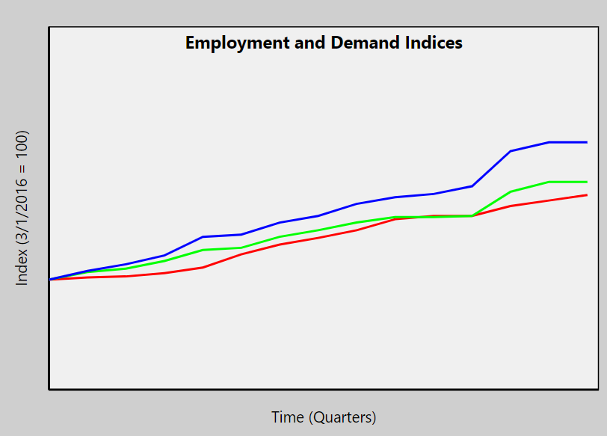

This line chart shows the trend in series Employment, Real domestic demand, and Nominal domestic demand from 3/1/2016 to 6/1/2023. The x-axis represents time in quarters, and the y-axis represents point values. The starting point, 3/1/2016, has been set at 100.

Key observation:

* There is, in general, an upsurge in all three indices within this period, indicating general economic growth.
* Where the blue line for nominal domestic demand rises most steeply, followed by green for Real domestic demand, and lastly, red for Employment.
* The dip in all three indices around the 15th-16th data point could clearly be seen, probably corresponding to early 2020 and reflecting the effects of the COVID-19 pandemic.
* Recovery from this also seems rapid, with all indices getting back onto their upward track.
* The gap between Nominal and Real domestic demand widens gradually over time, perhaps suggesting inflation.

This is the bar chart showing the Recovery Strength Index for the OECD from Q1 2020 to Q2 2023. Every bar shows a quarter-over-quarter percentage change in GDP. The quarters are plotted against the x-axis and the y-axis plots percentage change.

Key observations:

* There is one major negative bar in Q2 2020 that indicates a sharp economic contraction.
* That is then followed by a huge positive bar in Q3 2020, which accounts for the strong initial recovery when economies had begun to open.
* The succeeding quarters are dominated by smaller changes, largely positive, to reflect continued growth but at a more measured pace.
* The strength of recovery does appear to weaken as time progresses, and the recent quarters reflect smaller positive changes.
* There are a few quarters showing slight negative changes, so it looks like there are some bumps along the road to recovery (Jarvis et al., 2022).

# References

Aparicio, M., & Costa, C. (2014). Data Visualization. *Communication Design Quarterly*, *3*, 7–11. <https://doi.org/10.1145/2721882.2721883>

Barachini, F., & Stary, C. (2022). *Background and Motivation* (pp. 37–42). <https://doi.org/10.1007/978-3-030-96412-2_4>

Chen, B.-J., Causton, H., Mancenido, D., Goddard, N., Perlstein, E., & Pe’er, D. (2009). *Dataset 1*. <https://www.researchgate.net/publication/293839860_Dataset_1>

Chen, M., Floridi, L., & Borgo, R. (2013). *What Is Visualization Really For?* <https://doi.org/10.1007/978-3-319-07121-3_5>

Hamelryck, T., Kent, J., & Krogh, A. (2006). *Dataset S2*. <https://www.researchgate.net/publication/295000534_Dataset_S2>

Jarvis, P., Turner, A., Read, P., & Bishop, C. (2022). Reactive Strength Index and its Associations to Measures of Physical and Sports Performance: A Systematic Review with Meta-Analysis. *Sports Medicine*, *52*. [https://doi.org/10.1007/s40279-021-01566-y](%20https:/doi.org/10.1007/s40279-021-01566-y)

Juan Manuel Dodero. (2024). *Feature diagram with optional features.* <https://www.researchgate.net/figure/Feature-diagram-with-optional-features_fig1_215524997>

Olaitan, O. (2024). *DATA PROCESSING*. [https://doi.org/10.13140/RG.2.2.34785.68960](%20https:/doi.org/10.13140/RG.2.2.34785.68960)

Parul Gandhi. (2020). *Benefits of data visualization*. [https://www.researchgate.net/figure/Benefits-of-data-visualization_fig1_339685261#:~:text=Data visualization involves presenting data,terms of prediction and analysis.](https://www.researchgate.net/figure/Benefits-of-data-visualization_fig1_339685261%23:~:text=Data%20visualization%20involves%20presenting%20data,terms%20of%20prediction%20and%20analysis.)

Pászto, V., Redecker, A., Macků, K., Jürgens, C., & Moos, N. (2020). *Data Sources* (pp. 3–38). <https://doi.org/10.1007/978-3-030-26626-4_1>